**SE 3030 – Software Architecture**

Lab #5 – Presentation Layer Patterns

# Prerequisites

* Java SDK 7 (or above)
* Eclipse IDE with Java EE support - <http://www.eclipse.org/downloads/packages/eclipse-ide-java-ee-developers/neon2>
* Apache Tomcat 8 (or above) - <http://tomcat.apache.org/download-90.cgi>
* Knowledge on Java, MVC, Filter, View Helper, Singleton & other Basic Design Patterns

# Exercise 1 – Basic Java Web App

1. Create a Java Web Application
2. Eclipse > New Project > Dynamic Web Project
3. Add index.jsp
4. Create a basic login form

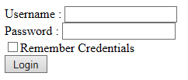

1. Deploy the Application on Tomcat server

# Exercise 2 – MVC

1. Model: Create a Java class for **User.java**
   1. Properties: firstName, lastName, email, phone, username, password, etc…
   2. Implement getters, setters
2. Controller: Create a Servlet to handle the Login Request
3. View: JSP
   1. Use the jsp from Exercise #1 as the landing page
   2. Create a new jsp to Display basic user details
4. Implement MVC with above and deploy on server

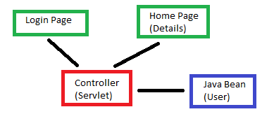

# Exercise 3 – User Authentication Service

1. Create an Interface for User Authentication Service
2. Implement the User Authentication Service
   1. Due to time limitations you can hardcode values instead of connecting to Database
3. Use Singleton Pattern (knowledge from previous labs) and integrate with Controller

# Exercise 4 – View Helper

1. Create a Helper Class called **DateTimeHelper.java**
2. Implement a method to get current Date/Time in **yyyy-MM-dd HH:mm:ss** format
3. Use the DateTimeHelper to display the Date and Time on the Home Page

# Exercise 5 – Filter

1. Create a Java Web Filter
2. Implement a sample Logger Filter
3. Integrate with Controller URL pattern
4. Research and find how to implement a Filter Chain in Java Web Apps
5. Present your findings to the Instructor